**Ideation Phase**

**Define the Problem Statements**

|  |  |
| --- | --- |
| Date | 25 June 2025 |
| Team ID | LTVIP2025TMID59691 |
| Project Name | Flightfinder |
| Maximum Marks | 2 Marks |

**Customer Problem Statement for Flight Finder**

To define the core problems travellers and operators face while booking or managing flights online, and use those insights to guide the development of Flight Finder.

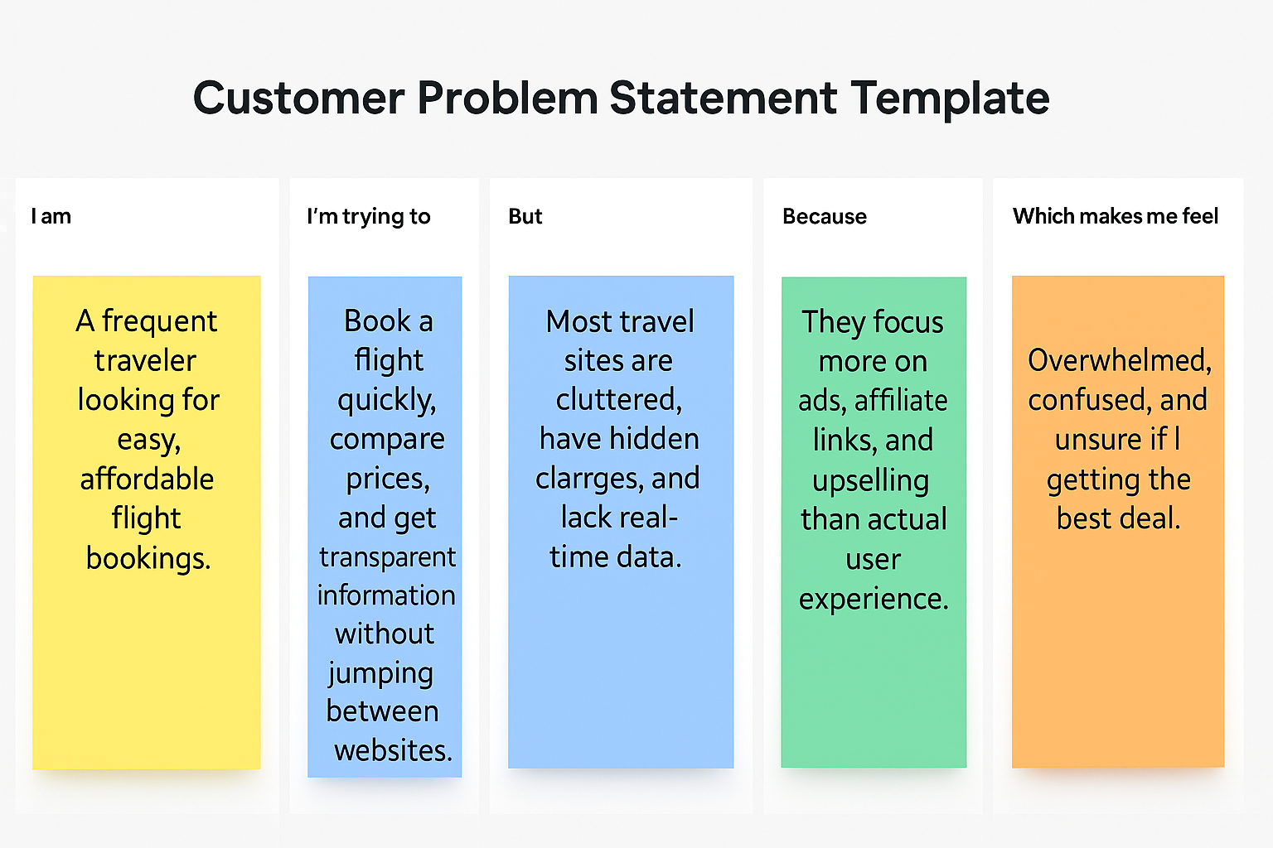

|  |  |  |  |  |  |  |  |  |  |  |  |  |  |  |  |  |  |  |
| --- | --- | --- | --- | --- | --- | --- | --- | --- | --- | --- | --- | --- | --- | --- | --- | --- | --- | --- |
| |  |  |  |  |  |  | | --- | --- | --- | --- | --- | --- | | **Problem Statement(PS)** | **I am**  **(Customer)** | **I’m trying to** | **But** | **Because** | **Which makes me feel** | | PS-1 | a busy working professional who often travels for work and leisure | find and book affordable flights easily with real-time info | most flight sites are cluttered or have hidden charges | they prioritize advertising and commissions over user convenience | frustrated, rushed, and unsure if I’m getting the best deal | | PS-2 | a flight operator or admin managing multiple daily flights | update flight info, view bookings, and track customer requests | existing systems are too expensive or not tailored to needs | they lack real-time, customizable tools suited for smaller operators | overwhelmed and unable to offer smooth and efficient service | |